**Scholarship Buddy**

Awarding scholarships doesn't have to be hard -- especially for nonprofits!

[Fork me on Github](https://github.com/epicfaace/ScholarshipBuddy)

**The team** **1**

**The Concept** **2**

Target Audience or Market 3

Personas 3

Feedback 4

**How it works** **5**

Core Technologies (front-end) 5

Core Technologies (back-end) 6

**The Business Plan** **6**

Competition 6

Business Model 7

**Additional Information** **8**

Demo 8

Screenshots 8

**Conclusion** **10**

# The team

We are twin brothers from Johns Creek, GA. We first came up with this idea after our experience applying to multiple scholarships during our senior year of high school. While some scholarship application websites were stellar, others weren't as secure or easy to use as they should be; and other nonprofits accepted scholarships by paper! We've been interested in computer science throughout our childhood and school years and thought that the Imagine Cup would be a great opportunity to create a platform that leverages the benefits of Azure to help nonprofits more easily create scholarships.

[**Ashwin Ramaswami**](https://epicfaace.github.io/)**,** Stanford, CS, Class of 2021 - Ashwin Ramaswami is a freshman at Stanford University. In his free time, he is a full-stack website and mobile app developer, and he is a Microsoft Certified Professional in HTML5, CSS3, and Javascript development. He also likes to do yoga and meditate. He plans to major in computer science.

[**Arvind Ramaswami**](https://www.linkedin.com/in/arvind-ramaswami)**,** Georgia Tech, CS, Class of 2021 - Arvind is a freshman at the Georgia Institute of Technology and is majoring in computer science, focusing on intelligence and theory. Arvind enjoys creating algorithms to solve challenging computational problems, and he has a strong passion in discrete math. He also played the violin as a member of the Atlanta Symphony Youth Orchestra.

**Mentors:**

**Our parents, Kalyani Sankaranarayanan and Sivaraman Ramaswami -** Our parents helped us throughout our entire journey! Ashwin first learned programming when his dad gave him an MSDN Article "C# for Kids" in 3rd grade. Throughout the process of developing the application and applying for the Imagine Cup, their help, feedback, and encouragement was necessary, appreciated, and useful.

**Shatul Parikh** - Shatul was our point of contact from the Indian American Scholarship Fund. He was essential in giving us the requirements their organization needed for a useful and valuable scholarship application and giving feedback on what we did well and what we could improve upon.

# The Concept

Isn't applying to all those scholarships in high school such a pain? Well, it's also a huge problem for the scholarship organizations themselves! Just think about it: successful scholarship application programs have to handle hundreds or thousands of applications, keep documents secure, and ensure an easy user experience for high school students.

Currently, there just isn't an easy solution for an organization to easily create an online scholarship application system and distribute it. Of course, you have custom vendor solutions by other companies. But, they are just too expensive for a relatively straightforward task! For example, SurveyMonkey Apply costs *at minimum* $3950 per year; small nonprofits cannot afford this. The other option is to hire a software engineering team to build a custom-made product, which is also expensive and not within many nonprofits' budgets. As a result, many nonprofits are stuck with using paper scholarship systems.

Our first use case was the Indian American Scholarship Fund, which was looking to move from paper applications to an online system -- but the existing options were just too expensive and not really what they wanted. We knew there had to be a better solution, especially for small nonprofit organizations. That is how we started developing Scholarship Buddy.

The goal of Scholarship Buddy is to be an extensible system that can easily be implemented by a nonprofit, which allows the following features:

* Scholarship account creation and form submission
* Review of existing applications by staff accounts
* Handling sensitive information (tax documents, etc.) in a secure manner
* Sending confirmation emails to applicants

We looked at different platforms such as AWS and Google Cloud, and chose Azure because it was the best fit for our requirements. Not only did it have an integrated solution for the specific requirements we needed, Microsoft also offers a $5000 yearly Azure credit for nonprofits. This would be the best place for a nonprofit who is just starting up a scholarship to begin to implement their application.

## Target Audience or Market

**Audience need**

Our audience is made of small nonprofits which want to create or modernize a scholarship application. Small nonprofits like these cannot afford to develop a complex product with a software engineering team, especially along with the entire process of building, testing, and software development lifecycle involved with creating a product from scratch. Many nonprofits either currently spend a significant share of their scholarship funds with developing the application portal itself, or have to stick with legacy systems or paper applications.

A solution such as Scholarship Buddy would greatly streamline the process of getting a scholarship application up and running, without the cost of hiring a large team to develop custom software or the risks of insecure, poorly coded systems or servers.

**Audience size**

According to a study done by CollegeBoard, private institutions and employers provided $15.9 billion in aid to undergraduates in the United States in the 2016-17 school year. This number has increased by 29% in the past 10 years. Evidently, there is a huge amount of money that is disbursed through private scholarship applications, and thus a large potential audience that would benefit from a more efficient scholarship application process.

However, private grants made up only 13% of current grant aid in 2016-17.[1] Perhaps if this process could be made more efficient and reach more people, more nonprofit and private organizations could take advantage of offering scholarships more easily through this system.

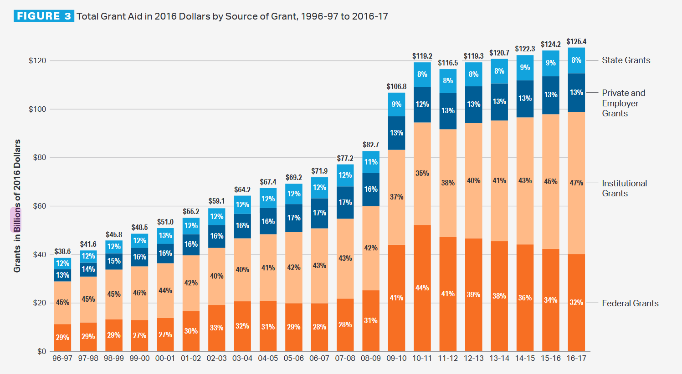

### Personas

**Savitri, a scholarship manager:**

Savitri has been a manager of the Tall People Scholarship for the past several years, and they have enjoyed giving scholarship to all tall people who perform exceptionally well in school and their community. It's a rewarding job and a great way to give back to the community!

However, she has been running into problems as her nonprofit has grown. Initially, they used a paper application, when the nonprofit was still small. However, it is getting unwieldy to accept paper copies of hundreds of applications, receive documents and count them from the mail, and distribute them to the entire scholarship review team. Moving the application to an electronic system would be ideal; however, if she did so, she would have to hire a software development team, too, which would take up a significant portion of the nonprofit's budget. What to do?

Scholarship Buddy is the perfect fit for her, as it lets her use a trusted, secure, and inexpensive solution to quickly scale and modernize the scholarship application technologies. She does not need to worry about storage of important documents as it is all managed by Azure Cloud Storage. All the infrastructure is handled and hosted by Microsoft and the server runs on Django, a tried-and-tested platform which she knows will be secure.

Additionally, she is able to create staff accounts for the scholarship review board, so that these people can log in to the website and review and rate the applications themselves. A win for her -- saving both paper and time!

**Subahu, a scholarship applicant:**

Subahu is a scholarship applicant. He has applied to dozens of scholarships so far his senior year of high school, but so far his experience has not been too great. For many of his scholarships, he has to print out a thick packet of required documents and mail it in the old-fashioned way, which is just a pain. And a waste of trees!

Even for the applications that are online, though, the user interface and experience is not optimal. Many times the page expires, or he refreshes and loses all his data. Moreover, he has to upload sensitive documents, while many of the sites do not even use SSL! Other sites look like they're from the 1990s, or are built from a bunch of half-cooked Wordpress plugins all jumbled together. There has to be a better way, Subahu thinks.

Now, Subahu decides to apply for the Tall People Scholarship, which is powered by the Scholarship Buddy framework. Immediately, he notices a huge difference. The user interface is intuitive and easy to use, so he is able to finish his scholarship quickly and more efficiently. He's able to finish parts of the application, save his progress, and go back to it later. It kind of feels like the Common App!

Thus, Subahu is able to have more time to work on his own projects -- whether that's a community organization, a mobile app, or another independent and creative project!

## Feedback

We have piloted Scholarship Buddy with the Indian American Scholarship Fund, a nonprofit organization that offers one-, two-, and four-year scholarships for students who graduated from a high school in Georgia.

They had multiple requirements, such as being able to handle different types of applications -- financial aid or merit, with different pages for both. Additionally, each application had to be multi-step with separate pages for information about each. These requirements helped us to design the system so that it would be extensible and able to support features such as multiple pages and custom validation.

They liked the intuitive and responsive user interface, and how the documents were stored securely. Generally, the interface was also easy to use by scholarship applicants. Another feature they suggested was the ability to not only view submitted applications, but exporting a submitted application as a PDF.

# How it works

**Architecture diagram:**

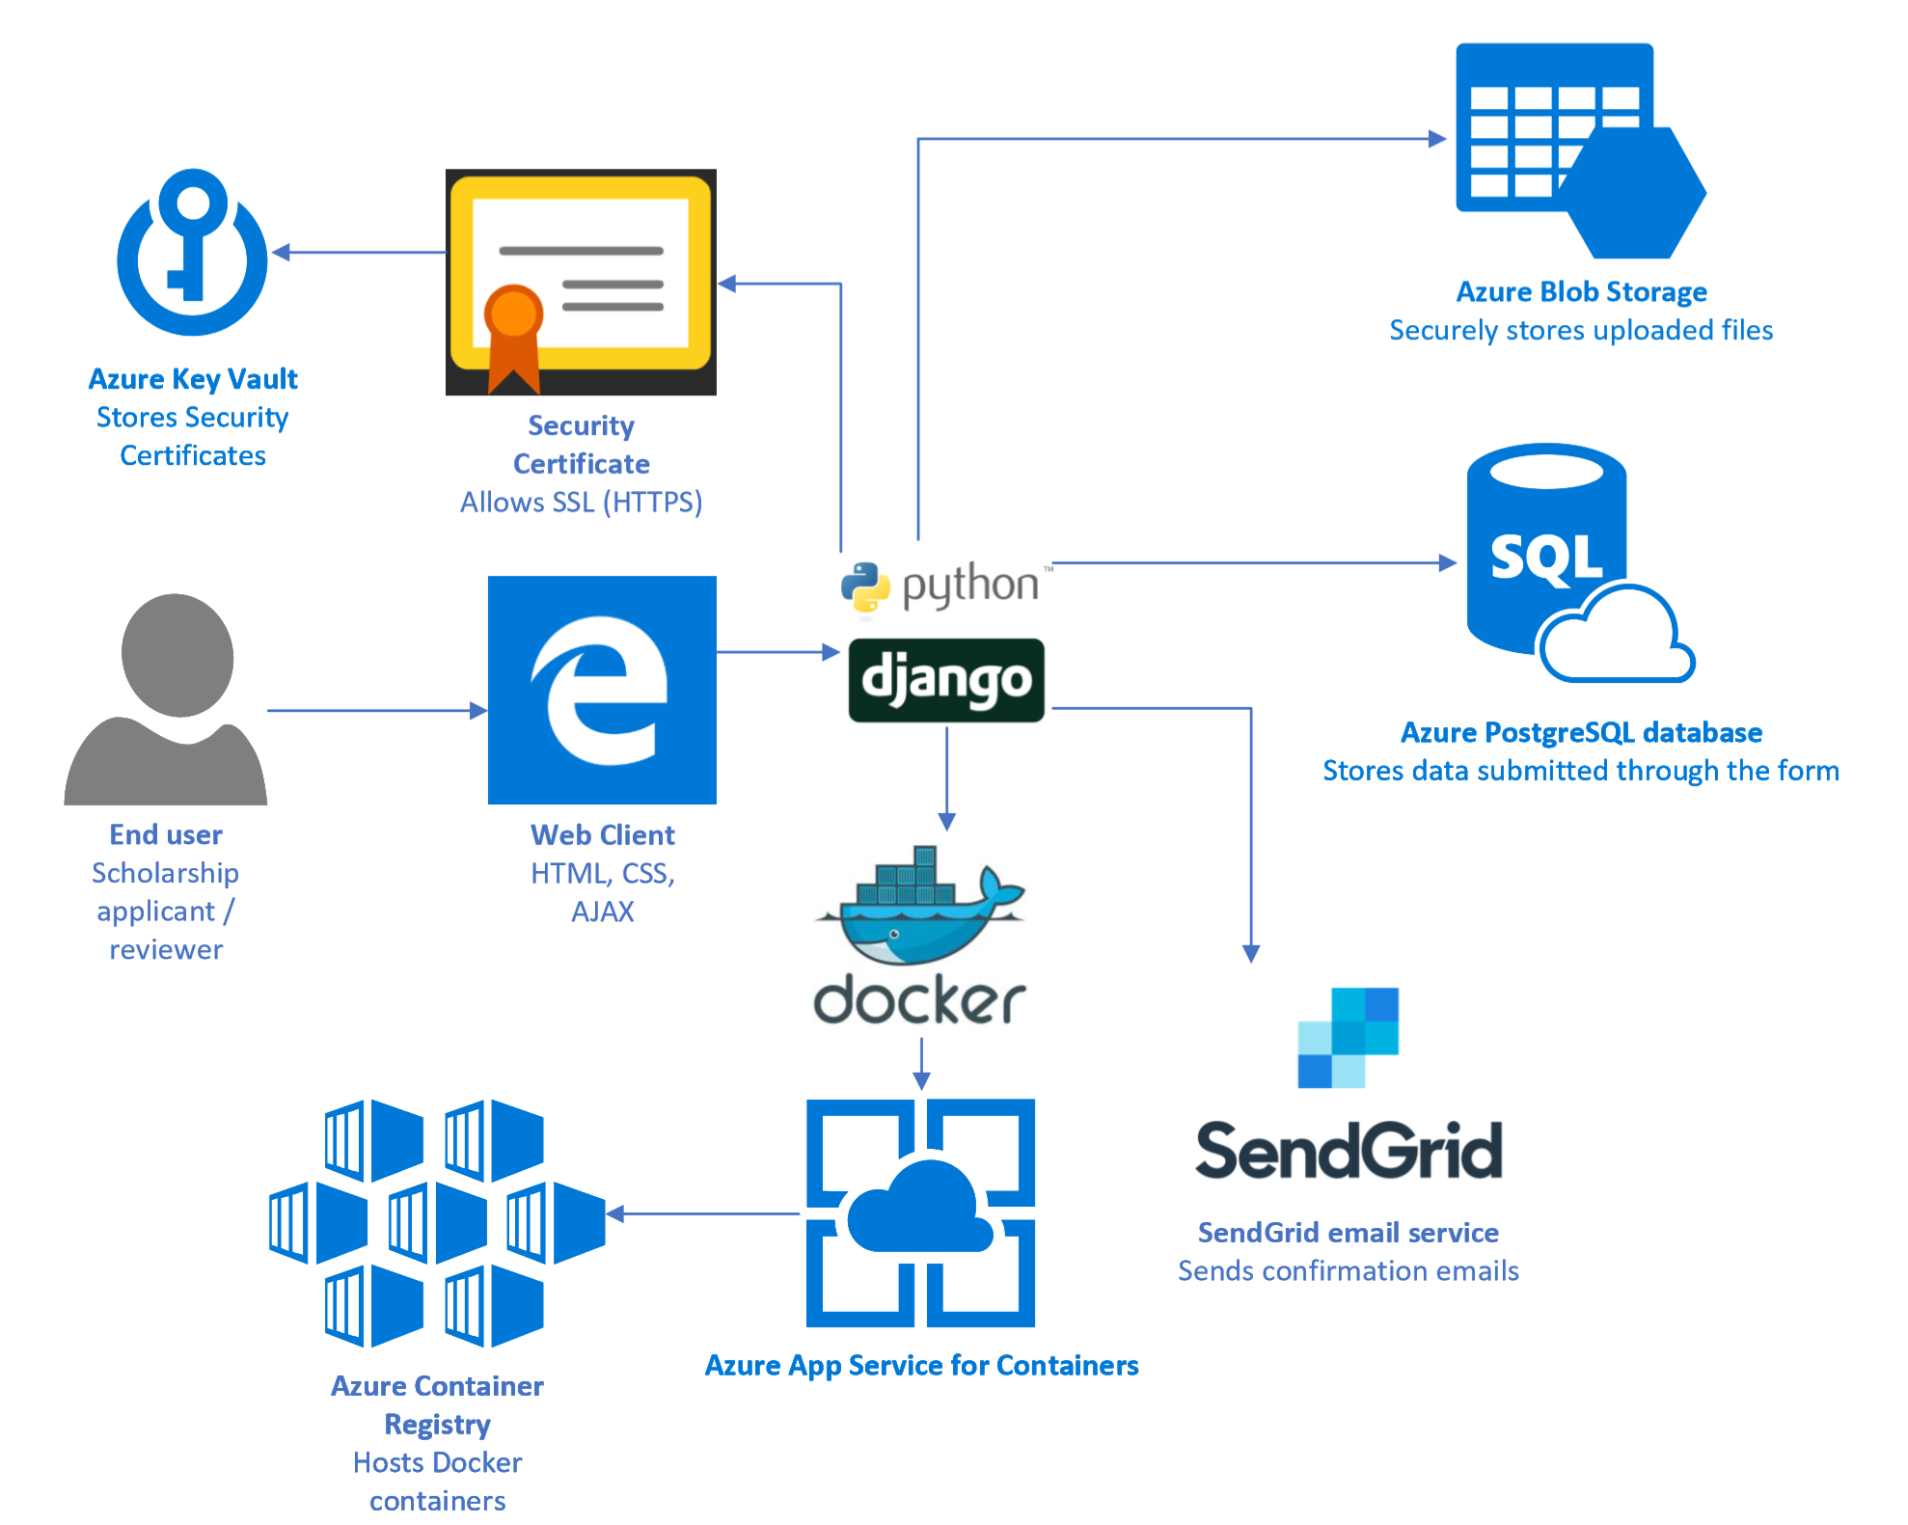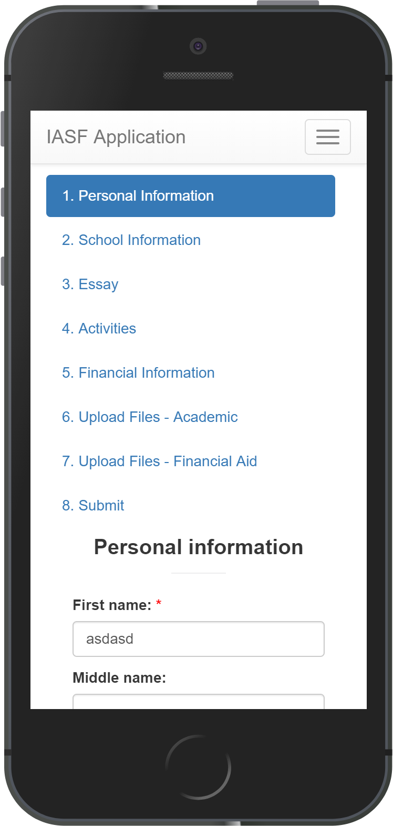

## Core Technologies (front-end)

The **end user** accesses the application through a **web client**, which is a web browser such as Microsoft Edge, Google Chrome, or Firefox, either on a computer or on a mobile phone.

Front-end technologies used to ensure a smooth and responsive user experience include **HTML5, CSS3,** and **Bootstrap** for *responsive design* to make it work well on mobile devices as well, as well as **jQuery** and **AJAX** to help make the transitions between different pages of the form seamless.

## Core Technologies (back-end)

The backend of the site is built in **Django**. Django is a widely used framework in Python used for web development and abstracts away many common tasks such as: user account creation, email sending, database queries with an ORM, and security features such as CSRF verification.

The Django website runs on a **Docker** container. Containerization on Docker allows for easier, more reliable, and more secure deployment to **Azure App Service for Containers.** The Docker container is registered and hosted at the **Azure Container Registry.**

Our code is hosted on a Git repository on **Visual Studio Online** and is set up to use **continuous integration**; whenever a commit is pushed to the server, it triggers a new build and deployment of a Docker container to our staging service. Finally, after testing out the staging site, we can deploy the site to production with a slot swap.

For secure storage of uploaded documents, the web server connects to **Azure Blob Storage.** Whenever a user wants to access an uploaded document (and assuming they have permissions to view it), they are given a temporary link from the Azure API that expires in a few minutes, ensuring security.

Emails (such as confirmation emails, notification emails, and password reset emails) are sent using **SendGrid**, which provides a scalable API for sending emails. SendGrid allows Azure customers to send 25,000 emails per month for free. This way, instead of needing to manage one's own SMTP server, one can leverage the power of SendGrid to send emails reliably and track statistics more easily.

# The Business Plan

## Competition

Our major competition is other managed form services. Unlike those services, however, our product is specifically designed to leverage Microsoft technologies while also providing an affordable solution for small nonprofits and organizations. For example, a competitor may be SurveyMonkey Apply. But their cheapest plan costs $3950 per year and only allows for up to 500 applicants and 10 reviewers. This kind of solution simply won't work for a small nonprofit on a shoestring budget.

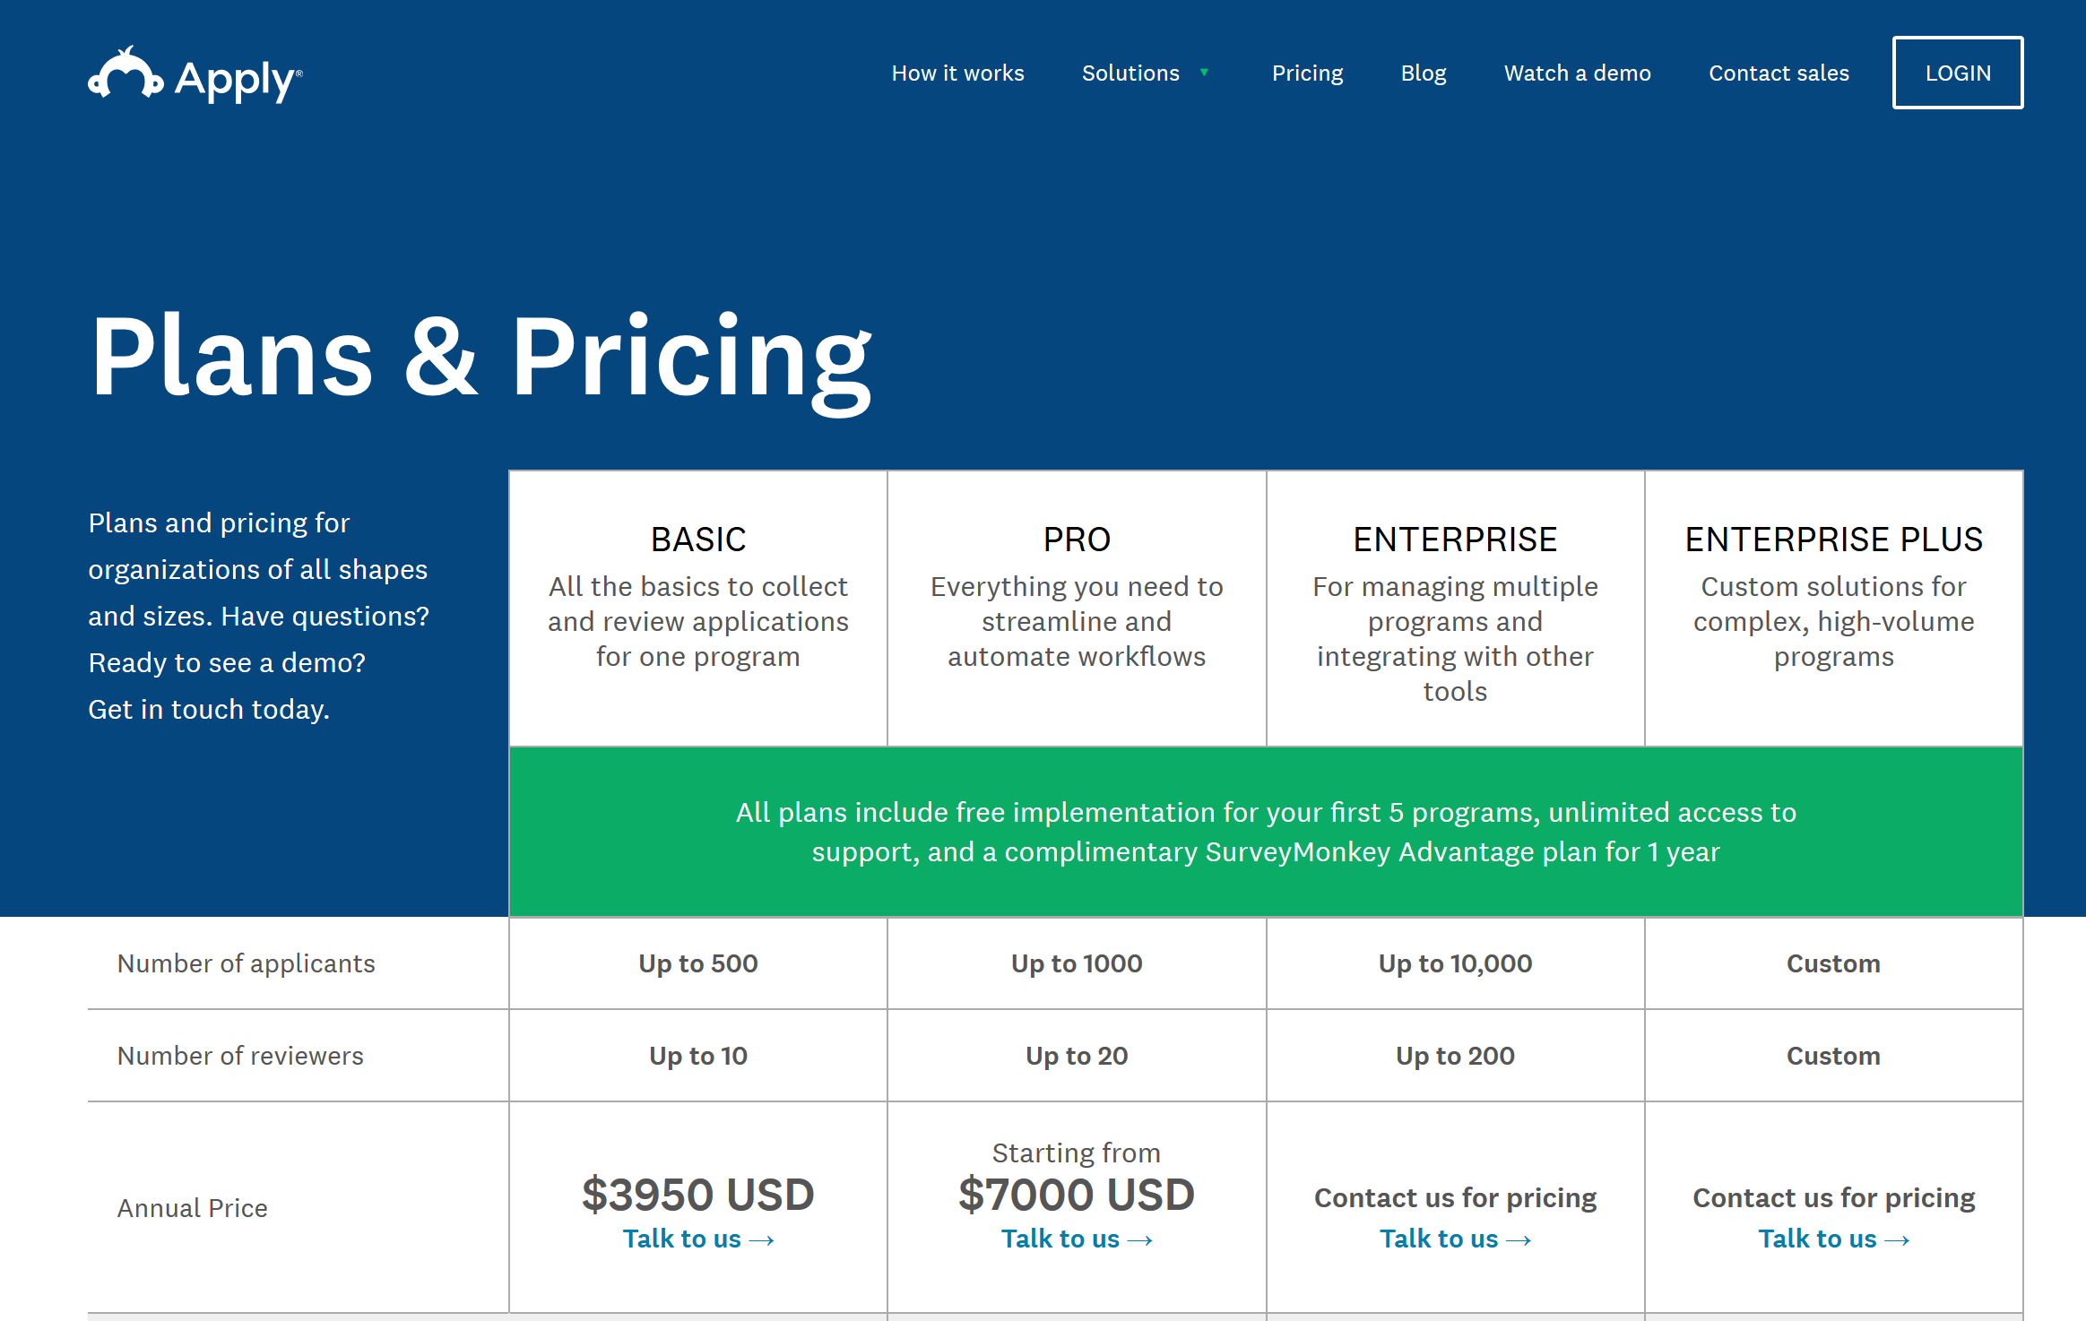

Evidently, there are many solutions for these problems available for enterprise, but a small nonprofit that is awarding scholarships simply cannot afford to buy a solution to the tune of thousands of dollars per year. A promising and viable avenue for nonprofits would be to use Scholarship Buddy, which would let them operate a full-fledged online scholarship application system much more easily and cheaply. With Microsoft's nonprofit sponsorship, these nonprofits can transition to this online system for free if they are small enough, or even if they are large enough to have to pay, at a much more reduced price than others.

Additionally, one huge factor that differentiates our product from existing solutions is **control**. When using a SaaS system such as SurveyMonkey, a nonprofit is locked in to using that software and cannot easily extend it. However, by using Scholarship Buddy, a nonprofit is directly able to manage resources on the Microsoft Azure cloud. This way, if they already have a software development team, they can work with the system and make improvements to it if they would like. Or, if they don't, they don't need to touch the settings at all. But, either way, using Scholarship Buddy gives them far more *flexibility* than using SaaS solutions.

## Business Model

**Sustainability**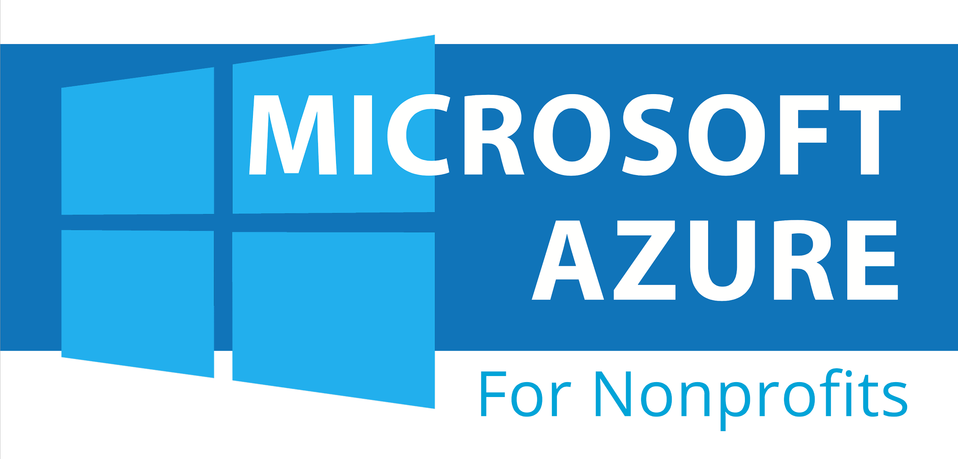

Our project will be provided as code that other nonprofits can use for free. It will be sustained by Microsoft's sponsorship of nonprofits, as they give $5,000 per year in Azure credits to nonprofits in their program (<https://www.microsoft.com/en-us/nonprofits/>).

Our hope is that by making the code available to the public, it can be developed as an open-source framework to bootstrap the development of online scholarship applications in general, and perhaps even broaden out to other types of applications.

**Value**

The value of Scholarship Buddy comes from its innovative and beneficial use of Microsoft's nonprofit sponsorship program. Nonprofits, whether small or large, will benefit.

If the nonprofit is small, they are able to use a free but reliable service to do their application. If the nonprofit is large and has to pay, they are still able to use a reliable system with reduced costs.

Additionally, it is a win-win situation both for Microsoft and nonprofits; while Microsoft is able to help out small nonprofits with minimal resources, it can form crucial partnerships with larger nonprofits that use this platform on a large scale and move on to the paid tier.

**Plan to Market**

Many nonprofits currently spend a significant share of their scholarship funds with developing the application portal itself. Many other scholarships are simply handled by paper. We aim to target both these kinds of nonprofits in the following ways:

Our plan for reaching more nonprofits is to first contact nonprofits that are currently using paper for their scholarship applications. By showing them the advantages in security and speed by using an electronic system, and, moreover, the fact that it would be free for small nonprofits, would help to convert more customers to using the product.

Eventually, we would reach out to organizations with existing scholarship application systems. Even a lot of these systems are outdated, or are costly to maintain. We could help them to move their application portals over to the Scholarship Buddy system because of the savings in cost, the modern and intuitive user interface, and increase in security with having a scholarship portal hosted on Azure.

# Additional Information

## Demo

The following site is a live use case of the framework being used for IASF scholarship:

<https://apply.iasf.org>

## Screenshots

Here are some screenshots from our demo:

**Sign-in page**

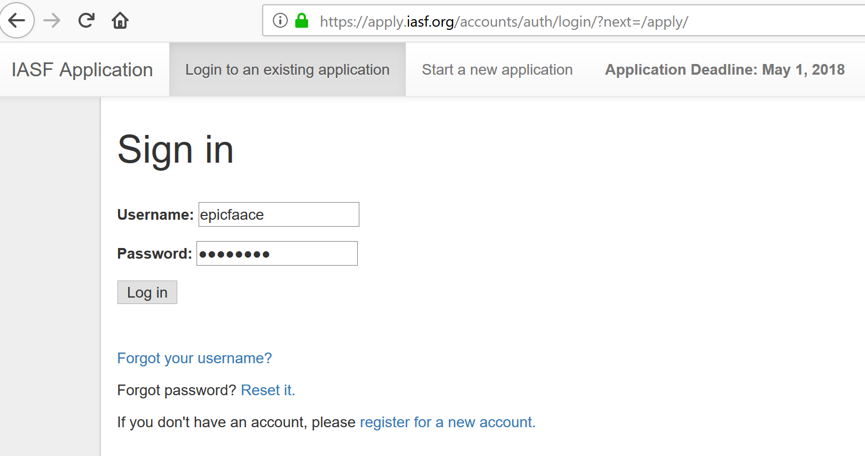

This is the sign-in page. Scholarship Buddy comes with the entire flow of users signing up for an account, then clicking on a confirmation link in their email to verify their account and start a new application.

**Application pages:**

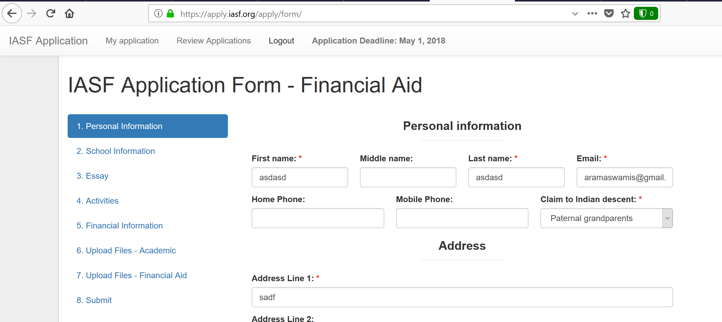

The application supports multiple pages and filling out part of the page for submission. Partially filled form data is saved using AJAX requests. Additionally, files such as transcripts and financial documents can be uploaded, which are stored in Azure Blob Storage. The Django server uses the libmagic library to make sure that no malicious files are uploaded.

**Application review by staff members:**

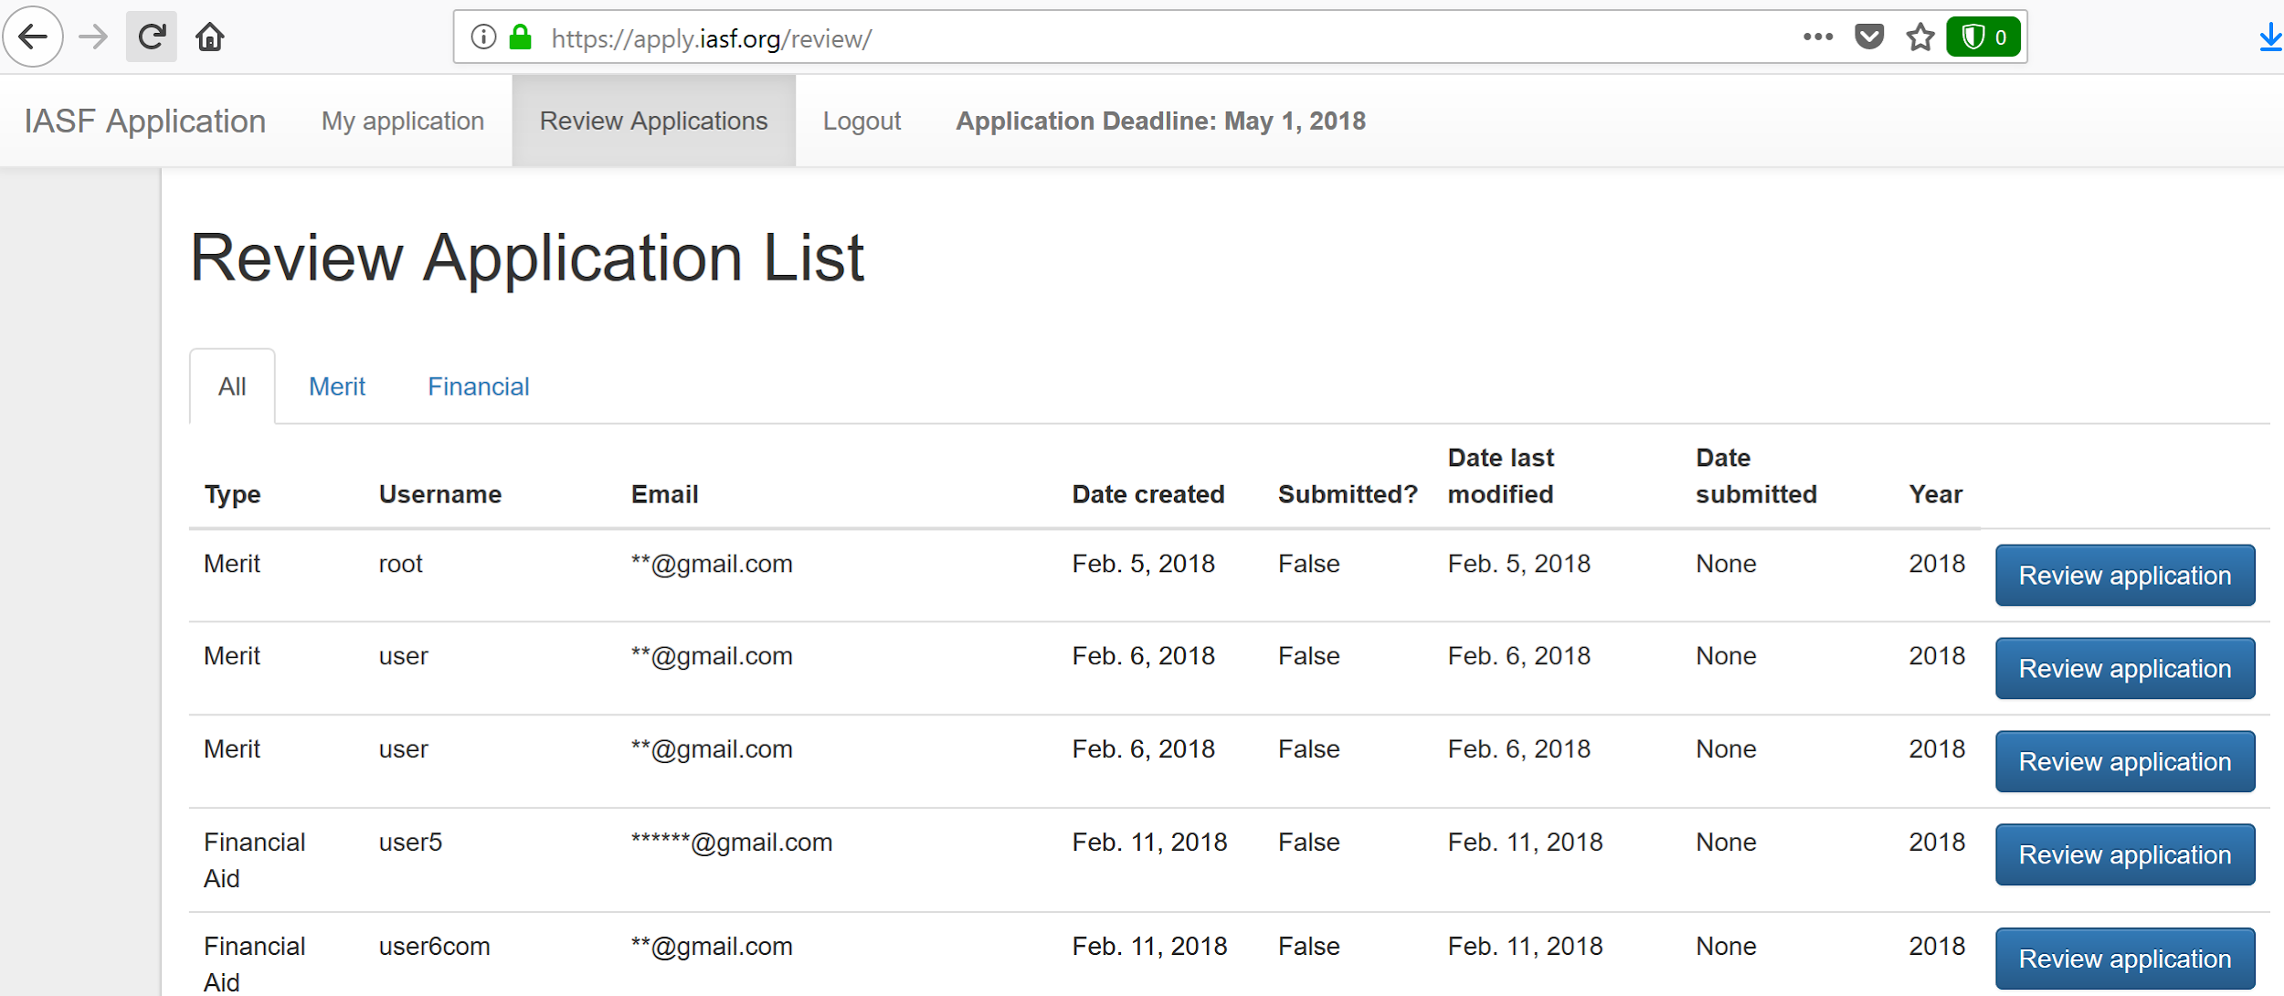

Staff members can log in and review applications in a secure application review portal.

**Administration page:**

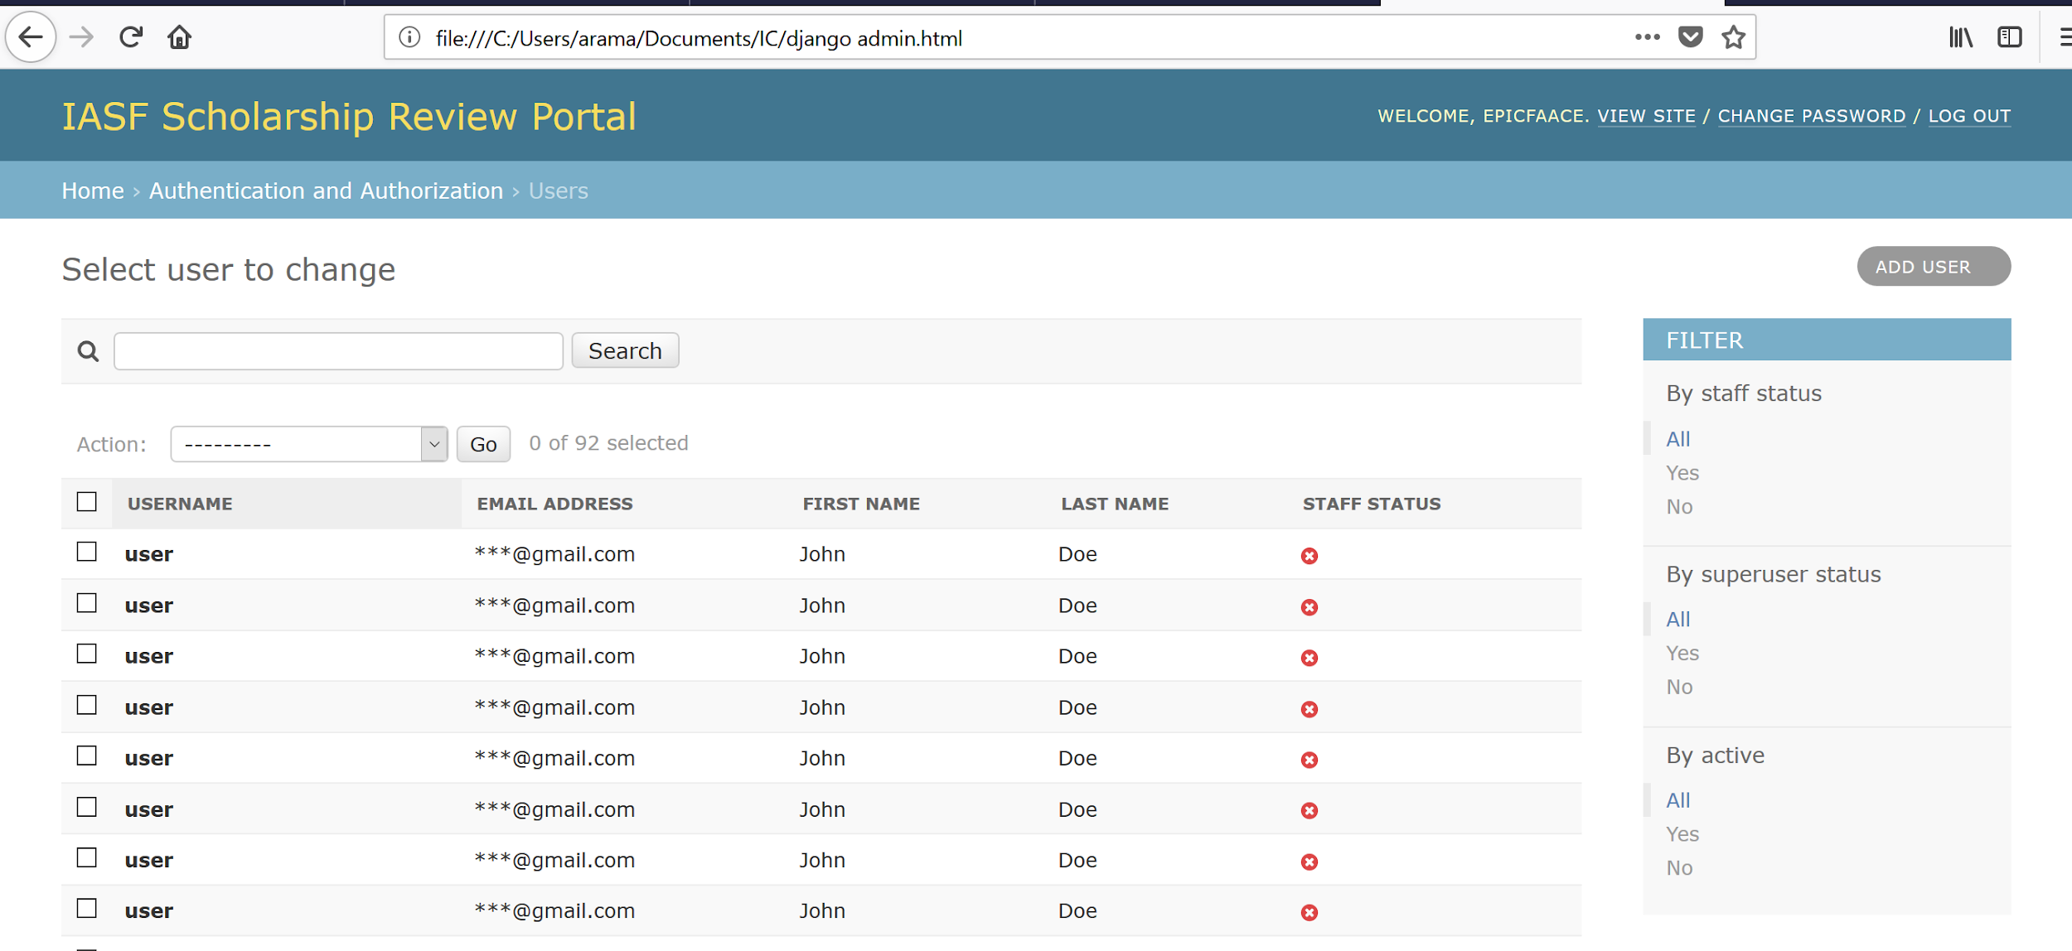

This administration page takes advantage of Django's built-in admin site functionality to allow a site administrator to manage individual users. By giving "staff status" to the accounts of the scholarship reviewers, the administrator is able to set up fine-grained access control to view individual applications.

# Conclusion

We believe that Scholarship Buddy can not only help make scholarship applications more secure, user-friendly, and consistent, but can also revolutionize the way in which nonprofits use technology. **Small nonprofits should not be treated as second-class citizens in the software development world.** They should not be denied access to the latest technologies because of their lack of expertise or funding for software development.

Microsoft has done its part by providing a sponsorship to let nonprofits get off the ground; now, Scholarship Buddy is one of the first of its kind in its goal of helping nonprofits deploy an existing solution with the confidence that it works and is secure. Efforts such as these will help nonprofits perform even better in their efforts to improve the lives of the people they work for.

1. <https://trends.collegeboard.org/sites/default/files/2017-trends-student-aid_0.pdf>